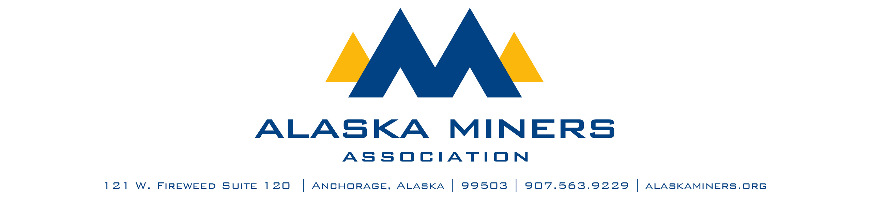
Alaska Miners Association Biennial Convention Banquet – Thursday, November 6, 2025
VOLUNTEER OF THE YEAR AWARD

AMA’s Individual Member of the Year Award honors an individual active in AMA who embodies the true strength of a membership-based organization. This award will recognize someone who has gone above and beyond to provide significant efforts to strengthen AMA and is a classic example of why members are the true lifeblood of AMA.
Criteria:
- Active in AMA events, membership, or committees
- Brings interest or new blood to AMA and strengthens or diversifies membership
- Goes to great effort to promote the organization
- Spends a significant amount of personal or professional time working on AMA activities
- Not compensated by the Alaska Miners Association

- Nominee Name
- Company
- Telephone Number
- Email Address
- Nominator Name
- Email Address
- Telephone Number

Please submit a letter of nomination that provides a description of this individual’s contribution to Alaska’s mining industry. Consider including:
- A description of the individual’s efforts in a generating awareness of AMA
- A description of how this person has assisted AMA staff and Board with a vital issue
- An account of how this individual contributes personal time to ensure the success of an event
- Details regarding this individual’s contributions to AMA through service and membership

Please limit submissions to fewer than 1,000 words. Submissions should be sent via email to Deantha@alaskaminers.org by close of business October 17, 2025. Applications will be reviewed by a committee comprised of the AMA Board Officers, AMA Executive Director, and Convention Committee Chairs. The winner will be announced at the banquet on November 6, 2025.

