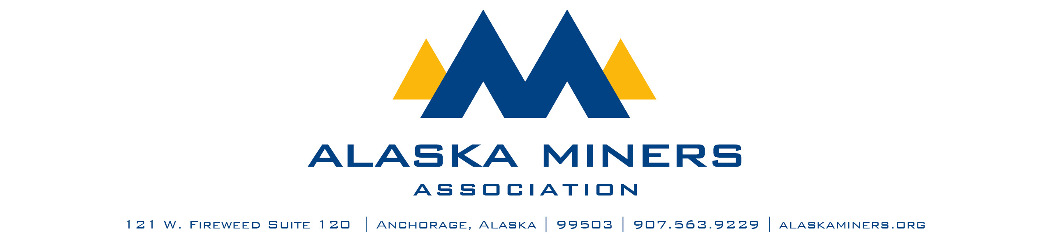
Alaska Miners Association Biennial Convention Banquet – Thursday, November 6, 2025
THE CHARLES C. HAWLEY LIFETIME ACHIEVEMENT AWARD
The Charles C. (Chuck) Hawley Lifetime Achievement Award is named in honor of the longtime AMA member and former Executive Director Emeritus who dedicated his entire career to advancing Alaska’s mining industry. This award seeks to recognize the service contributions of a mining industry pioneer, individual, or employee who, like Chuck, devoted his professional life to ensuring a successful mining industry in Alaska. This award will honor the dedication and success Chuck exemplified during his career: devotion of time, effort, thought, and action consistently shown in his mining industry service, perseverance and ambition, and a love for educating Alaskans on mining industry endeavors.
Criteria:

- At least 15 years of service in Alaska’s mining industry
- Made significant and lasting contributions to Alaska’s mining industry
- Devotion of decades to prospecting, exploration, development, or operations
- Outstanding contributions to Alaska and his or her local community

- Nominee Name
- Company
- Telephone Number
- Email Address
- Nominator Name
- Email Address
- Telephone Number

Each nomination should include at least one photo and a letter detailing the nominee’s contributions to Alaska’s mining industry that make them eligible for this award. Additional letters of support are encouraged. Consider including:

- A description of the nominee’s career.
- Details about the substantial contributions he or she has made to the mining industry
- A story about the nominee that illustrates his or her dedication to Alaska mining
Please limit submissions to fewer than 1,000 words. Submissions should be sent via email to Deantha@alaskaminers.org by close of business October 17, 2025. Applications will be reviewed by a committee comprised of the AMA Board Officers, AMA Executive Director, and Convention Committee Chairs. The winner will be announced at the banquet on November 6, 2025.

