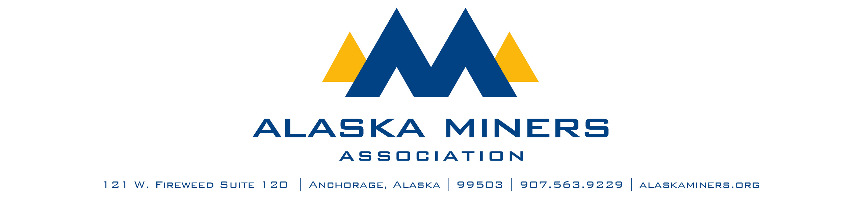
Alaska Miners Association Biennial Convention Banquet – Thursday, November 6, 2025
ROCK STAR OF PUBLIC SERVICE AWARD

AMA’s Public Service Award honors an individual working in the public sector with outstanding service interacting with Alaska’s mining industry. This individual may work at a state or federal regulatory agency, administrative branch, legislative branch, local government, or other public entity. This award will recognize someone who has gone above and beyond to work with miners to continue or improve the industry’s presence in Alaska and achieve shared results for Alaska’s economy, communities, and residents. Their unwavering dedication to their mission serves as an inspiration to others.
Criteria:
- Individual must be employed in the public sector
- Has demonstrated dedication, competence, flexibility, innovation, and collaboration on goals mutual to the industry and the public, resulting in positive and sustainable outcomes
- Is regularly present at AMA events, meetings, and other industry gatherings and continuously engages with Alaska’s miners

- Nominee Name
Company
- Telephone Number
- Email Address
- Nominator Name
- Email Address
- Telephone Number

Please submit a letter of nomination that provides a description of this individual’s contribution to Alaska’s mining industry. Consider including:
- A description of the individual’s efforts in working together with miners on environmental, safety, social, or other issues affecting the industry and surrounding community
- A description of how this person works to assist miners while meeting their entity’s mission
- A description of how this person has actively worked to bridge gaps and exhibit exceptional leadership qualities and unwavering integrity in their role
- An account of how this individual contributes time to engage with AMA and its members
- Any other details that highlight why this individual deserves to be recognized

Please limit submissions to fewer than 1,000 words. Submissions should be sent via email to Deantha@alaskaminers.org by close of business October 17, 2025. Applications will be reviewed by a committee comprised of the AMA Board Officers, AMA Executive Director, and Convention Committee Chairs. The winner will be announced at the banquet on November 6, 2025.

