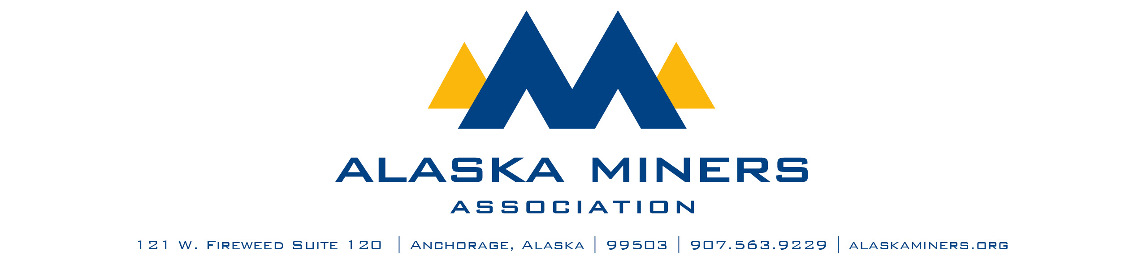

**Alaska Miners Association Biennial Convention Banquet – Thursday, November 6, 2025**

**ADVOCATE OF THE YEAR AWARD**

AMA’s Advocate of the Year Award honors an individual active in AMA who embodies the true strength of a membership-based trade association, demonstrating that through volunteer efforts and talents, high-caliber results are achieved. This award will recognize someone who has gone above and beyond to provide significant efforts to strengthen an advocacy effort on behalf AMA and is a classic example of why members are the true lifeblood of AMA.

Criteria:

* Active in AMA committees and provides insight and expertise to educate AMA staff, Directors, and membership on technical issues
* Contributes time and talent to AMA efforts requiring experts on the subject matter
* Spends a significant amount of personal or professional time working on AMA issues
* Not compensated by the Alaska Miners Association

|  |  |
| --- | --- |
| * Nominee Name |  |
| Company |  |
| * Telephone Number |  |
| * Email Address |  |
| * Nominator Name |  |
| * Email Address |  |
| * Telephone Number |  |

Please submit a letter of nomination that provides a description of this individual’s contribution to Alaska’s mining industry. Consider including:

* A description of the individual’s efforts in assisting AMA with issue education, formation of formal comments or testimony, or other participation
* A description of how this person has assisted AMA staff and Board with a vital issue
* An account of how this individual contributes personal time to ensure the success of AMA
* Details regarding this individual’s contributions to AMA through service and membership

Please limit submissions to fewer than 1,000 words. Submissions should be sent via email to Deantha@alaskaminers.org by close of business October 17, 2025. Applications will be reviewed by a five-person committee comprised of the AMA Board Officers, AMA Executive Director, and Convention Committee Chairs. The winner will be announced at the banquet on November 6, 2025.