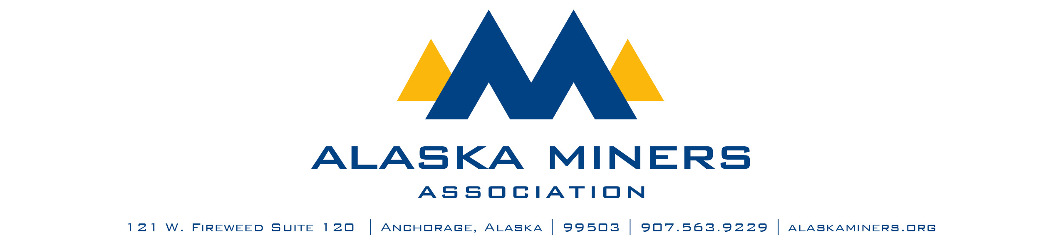

**Alaska Miners Association Biennial Convention Banquet – Thursday, November 6, 2025**

**HARD HAT SAFETY AWARD**

AMA’s Hard Hat Safety Award honors a group or person active in AMA who demonstrates an exemplary commitment to safety. The award recipient will demonstrate the highest safety standards, communication of safety policies and training, and have an exemplary record of incident-free days, hours, or other milestones. Awards may go to an operating mine, project, or contractor/vendor who services the mining industry in Alaska.

Criteria:

* Current member of the Alaska Miners Association
* Exemplary safety practices at site
* Efforts undertaken to enhance safety at site surrounding the area of operation at site
* Examples of going beyond permit requirements to ensure highest level of safety

|  |  |
| --- | --- |
| * Nominee Name |  |
| * Company |  |
| * Telephone Number |  |
| * Email Address |  |
| * Nominator Name |  |
| * Email Address |  |
| * Telephone Number |  |

Please submit a letter of nomination that provides a description of this contribution to Alaska’s mining industry. Consider including:

* A description of efforts or project that demonstrates the highest safety standards
* Description of employees, workforce, and hours worked if applicable
* An account of how this entity communicates safety in the workplace and trains workforce to regard safety
* Highlight of company/individual/project safety record
* If applicable, photos of the project, practice, etc.

Please limit submissions to fewer than 1,000 words. Submissions should be sent via email to Deantha@alaskaminers.org by close of business October 17, 2025. Applications will be reviewed by a committee comprised of the AMA Board Officers, AMA Executive Director, and Convention Committee Chair. The winner will be announced at the banquet on November 6, 2025.